Trustees regularly consider grant application from those who live within the boundaries of the catchment area shown overleaf with the criteria being those "who are in conditions of need, hardship and distress by making grants of money or providing or paying for items, services or facilities, calculated to reduce the need, hardship and distress of such persons".

Applications can only be made via a ‘Support Worker’ (an individual acting on behalf of an appropriate agency providing support to applicant’s or an organisation).

Applications can be submitted at any time – preferably by email - using this simple application form (available in Word format at www.johndorkincharityipswich.co.uk).
Once a grant has been received, it will be considered by the trustees who will inform you if this has been successful or not. Additional information may be requested as necessary.

You are able to email mail@johndorkincharityipswich.co.uk if you have any queries about making an application and the process.

Examples of where funding has been provided include;

For Individuals/Families
Redecoration – Carpeting – Curtains & Furnishing – Furniture & Kitchen Goods – Toys – Counselling – Children to attend residential camps/holidays/trips – Subscriptions for Clubs – Specialist Equipment – Basic Essentials

For Organisations
Community Projects / Events / Toys / Cooking Equipment

Please note that Trustees are unable to consider outstanding debts, or in the relief of rates, taxes or other public funds and may not commit themselves to repeat or renew relief granted on any occasion in any case.

Where grants are agreed, trustees can make payment by several different methods
- By BACS payment following receipt of invoice to supplier / Card payment to the supplier
- By BACS payment to your organisation
Payments are not made payable to the applicant’s

Important points to remember
Q6. – please ensure you detail how much money you are requesting. Estimates are generally needed and should be emailed / sent with the application form to support the request. Carpet estimates (2) are essential and where stairs/landings are being considered must include and show fitting costs.

Q7. – an important section where you make your case for funding and you need to clearly outline the reasons why you feel trustees should consider this application.

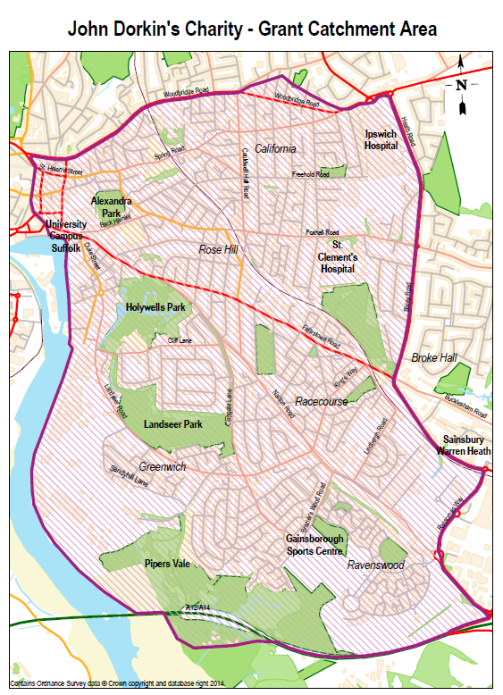

This form should be completed by a Support Worker and signed by the Applicant(s)

Agency/Organisation/Team submitting this application.
Postal Address

Name of Support Worker leading on this application
Email / Contact Numbers

1. | Full name of Applicant’s
2. | Applicant’s Date of Birth & Gender
3. | Applicant’s Email / Telephone
4. | Names and date of birth of any children and/or family at this address
5. | Full address of Applicant’s  (including postcode)
6. | Details of grant application including  - how much is being requested  - what is being requested and for what purpose  Please be specific and where possible provide written quotes or estimates
7. | Please provide examples of hardship and distress.  You need to outline to the trustees why you feel they should consider this application.
8. | Other agencies / organisations working with the applicant(s)
9. | Have any other organisation been approached for a grant in relation to this, and if so to whom and with what result?

Terms and Conditions
- Where possible the John Dorkin Charity will be acknowledged on publicity / annual reports etc.
- All staff / volunteers working with children / vulnerable adults will have appropriate checks carried out including an enhanced DBS disclosure. Organisations will have a Safeguarding Policy/Procedures.
- If the trustees have concerns regarding safety of vulnerable persons they will inform the appropriate authorities.
- It is the responsibility of the Support Worker to ensure that any grant is used solely for the purpose for which it was applied for. In the event of this funding – in full, or part – not being needed for the purpose of grant the grant will be returned to the Trustees.
- I confirm that to the best of my knowledge that the above information is correct, and have read and understood and agree to abide by the terms and conditions as detailed above.

(Signed)……………………………………………….. (Dated) …………………………………
Support Worker

DATA PROTECTION

Privacy Statement - using your personal information
- Personal information which you supply to us will only be used for consideration of the grant and future applications within a period of five years.
- If goods or services are granted we will share only your name and address with suppliers for the sole purpose of ordering and delivering the goods.
- For further information on how your information is used, how we maintain the security of your information, your rights to access information we hold on you or if you wish to request that your data be deleted, please refer to the attached Privacy Notice or contact the Charity Manager at data@johndorkincharityipswich.co.uk or in writing to John Dorkin Charity, Trinity Bungalow, 20 Back Hamlet, Ipswich, IP3 8AJ.

Applicant(s)’ declaration

- I agree to the Charity using my personal information as shown in the Privacy Statement above and the Privacy Notice appended to this form and available at www.johndorkincharityipswich.co.uk
- Trustees may know of other agencies or third parties who may be able to provide assistance. These include: Local Councillors: Families in Need (FIND). Are you willing for the information on this application to be shared with them? YES / NO

(Signed)……………………………………………….. (Dated) …………………………………

(Signed)……………………………………………….. (Dated) …………………………………

(if under 16 years of age to be signed by person holding parental responsibility)

